Sanaad Mobile Application
User Authentication &
Access Control API Framework

Version | Author | Date
1.0.0 | Vandana Pavithran | 2 Jan 2026

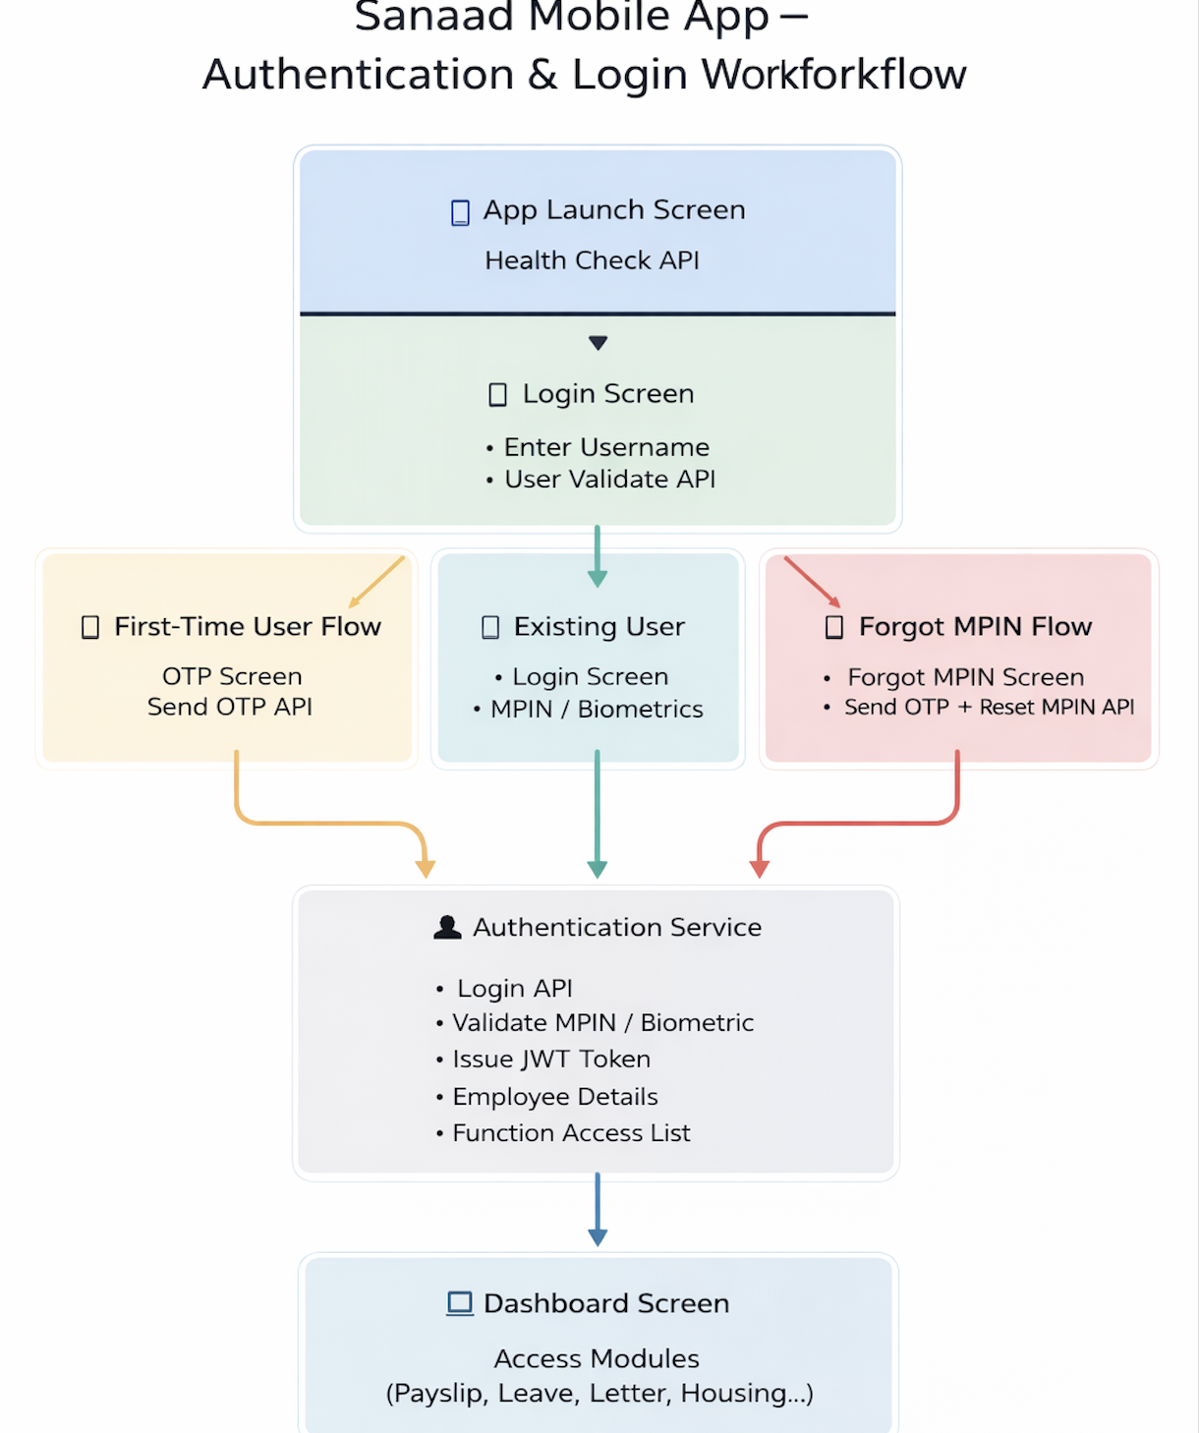

1. Introduction
This document defines the Authentication & Security APIs for the Sanaad Mobile Application.
It covers:
- First-time user onboarding
- Existing user login
- OTP verification
- MPIN creation & reset
- Biometric enablement
- JWT-based authentication
- Audit & security considerations

The solution ensures a secure, auditable login journey with strong identity verification and role-based module access.

2. High-Level Login & Security Flow
App Launch → Health Check API
Login Screen → User Validate API
First-Time User → OTP + Set MPIN + Login
Existing User → Login with MPIN / Biometrics
Forgot MPIN → OTP + Reset MPIN
All key events are audited.

3. API List Overview
API-1: Health Check API
API-2: User Validate API
API-3: Send OTP API
API-4: Set MPIN API
API-5: Login API
API-6: Forgot MPIN – Reset MPIN API

4. API Specifications & JSON Payloads
Detailed request and response JSON payloads for all APIs are included below.

API-1: Health Check API (App Launch)
- Called automatically when the user opens the Sanaad app.
- Checks whether the backend services are available or under downtime.
- Returns whether the user must update the app (mandatory / optional / not required).
- Internally logs an audit entry with device, app version, and status.
- Controls whether the app should proceed to the Login screen or show a maintenance/update message.

Request:
{
"deviceimei": "356789012345678",
"platform": "Android",
"sysdate": "2026-01-02T14:10:00",
"appname": "Sanaad",
"version": "1.0.0"
}

Response:

{
"appDowntime": "No",
"downtimeStart": "",
"downtimeEnd": "",
"updatetype": "R"
}

{
"appDowntime": "Yes",
"downtimeStart": "2026-01-17 11:00:00.0",
"downtimeEnd": "2026-01-18 00:00:00.0",
"updatetype": "M"
}

URL: /sanaad/healthcheck
Method: POST

API-2: User Validate API
- Called after the user enters their username on the Login screen.
- Validates whether the username exists in LDAP system.
- Determines whether the user is a new (first-time) user or an existing user.
- Confirms whether the user is a valid employee (eligible to use Sanaad).
- OTP will be sent to user’s registered mobile number.

Request:
{
"username": "employee nt id",
"imeinumber": "35678901234567999923111",
"platform": "Android",
"sysdate": "2026-01-24T09:15:00",
"appname": "Sanaad",
"version": "1.0.0"
}

Response:
{
"employeeusername": "employee nt id",
"employeename": "Name of employee",
"newuser": "Yes",
"employeeflag": "Yes",
"employeephonenumber": "7786XXXX",
"requestid": "35233177903C44859C82269212F48088"
}

{
"status": "error",
"message": "Pending Employee Registration for device"
}

{
"status": "error",
"message": "Invalid employee id received."
}

URL: /sanaad/auth/initiate
Method: POST

API-3: Validate OTP API
- Called after successful username validation for first-time users or Forgot MPIN flow.

Request:
{
"username": "hmc12345",
"imeinumber": "356789012345678",
“otp”: “232323”,
“requestid”: “13131313123”,
"sysdate": "2026-01-02T14:15:00",
"appname": "Sanaad",
"version": "1.0.0"
}

Response:
{"status": "success", "message": "OTP Validated successfully"}
{"status": "error", "message": "Invalid OTP"}

API-4: Set MPIN API
- Used in the first-time user onboarding flow after OTP has been successfully verified.
- Accepts the new MPIN chosen by the user and binds it to the username + device.
- Applies MPIN policy rules (length, complexity, allowed patterns).
- Stores the MPIN securely in the backend (hashed + salted).
- On success, completes MPIN registration, enabling the user to log in using MPIN.
- Acts as the trigger point after which the app can offer to enable Biometrics.

Request:
{
"username": "hmc12345",
"imeinumber": "356789012345678",
"phonetype": "Android",
"username": "hmc12345",
"sysdate": "2026-01-02T14:15:00",
"mpin": "1234", {Shamim ; this will be hashed by kony and passed on api}
"appname": "Sanaad",
"version": "1.0.0"
}

Response:
{"status": "success", "message": "MPIN updated successfully"}
{"status": "error", "message": "Failed to update MPIN"}

URL : /sanaad/auth/mpin/update
METHOD : POST

API-5: Login API
- Main authentication API for both first-time and existing users.
- Validates the user’s MPIN (or MPIN-equivalent when biometric is used).
- Issues a JWT access token and expiry time on successful authentication.
- Returns employee details (number, name, department)
- Returns a functionAccessList array showing which modules are ENABLED / DISABLED / COMING_SOON (e.g., Payslip, Leave, Letter, Housing).
- Drives UI behavior (what to show/enable) while backend still enforces authorization.
- All login successes and failures should be audited for security/compliance.

Request:
{
"username": "empid",
"imeinumber": "356789012345679999231123",
"mpin": "555407",
"appname": "Sanaad",
"version": "1.0.0",
"sysdate": "2026-01-02T14:20:00"
}

Response:
{
"status": "success",
"employeenumber": "3242424",
"employeename": "name of employee",
"employeenamear": "name of employee arabic",
"employeedepartment": "Information Communication and Technology",
"employeecompany": "Health Information and Communication Technology",
"functionaccesslist": [
{
"functionname": "Payroll SSRS",
"functioncode": "PYSRS",
"remarks": "Payroll SSRS",
"status": "1",
},
{
"functionname": "Staff Clinic Apptmnt",
"functioncode": "SDCAPT",
"remarks": "Staff Clinic Appointmnt",
"status": "1",
},
]
}

URL : /sanaad/auth/login
Method : POST

API-6: Initiate Forgot MPIN – Initiate Reset MPIN API
Request:
{
"username": "hmc12345",
"imeinumber": "356789012345678",
"appName": "Sanaad",
"appVersion": "1.0.0",
"sysdate": "2026-01-02T14:35:00"
}

Response :
{
“status”: “initiated successfully”,
“requestid”: “13131313123”
}

API-7: Forgot MPIN – Reset MPIN API
- Used when an existing user forgets their MPIN and chooses to reset it.
- Called after an OTP is sent and the user enters OTP + new MPIN + confirm MPIN.
- Validates the OTP, device (IMEI), and MPIN policy.
- Updates the user’s MPIN securely in the backend (overwriting old MPIN).
- Returns a simple flag indicating whether MPIN reset was successful.
- Logs audit events indicating MPIN reset success/failure and reason (errorCode).

Request:
{
"username": "hmc12345",
"imeinumber": "356789012345678",
"requestid": "13131313123",
"newmpin": "4321",
"otp": "987654",
"appName": "Sanaad",
"appVersion": "1.0.0",
"sysdate": "2026-01-02T14:35:00"
}

Response:
{
"status": "error",
"message": "Invalid OTP"
}

{
"status": "success",
“message” : “MPIN Changed successfully”
}

URL : /sanaad/auth/mpin/update/reset
Method : POST

5 Audit & Logging Framework
The Sanaad Mobile Authentication framework maintains a comprehensive, multi-level audit trail to ensure traceability, compliance, security monitoring, and readiness.Audit logging applies to all authentication events and security-sensitive operations.Every Authentication & Business API must internally trigger its corresponding audit logging transaction from the backend layer.”
This applies to:
- Health Check API
- User Validate API
- Send OTP API
- Set MPIN API
- Login API
- Forgot MPIN Reset API
- ALL Business APIs such as:Payslip ,Leave,Letters etc.

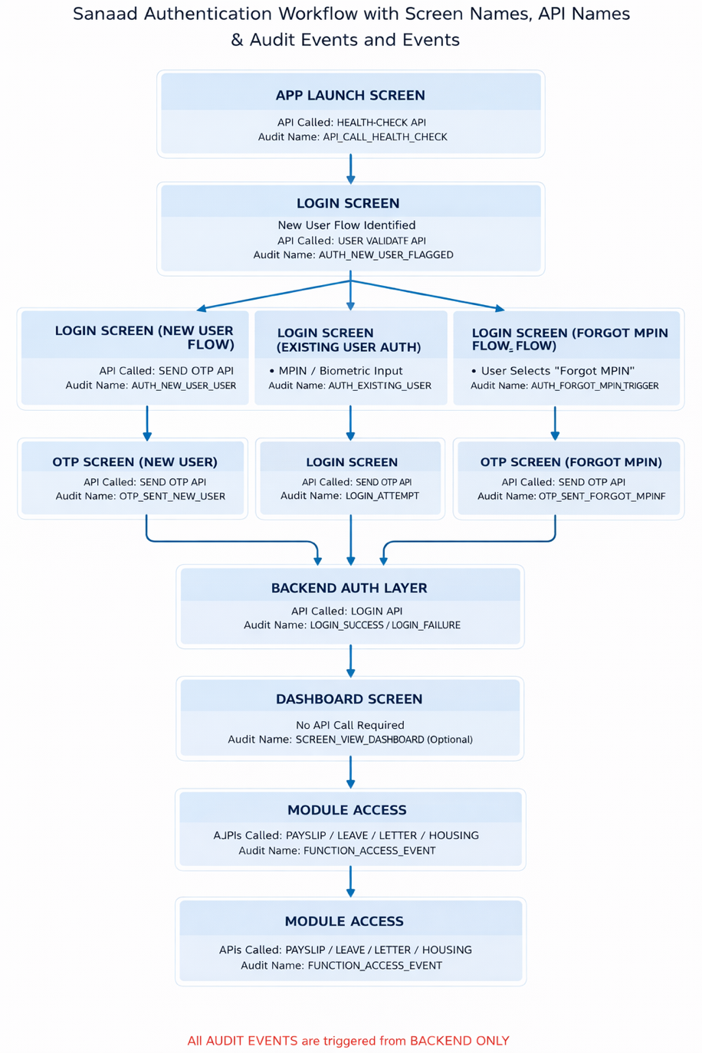

5.1 Objectives of Audit Logging
Audit logs are designed to:
• Track user identity & activity across devices
• Detect abnormal login / OTP / MPIN behavior
• Support InfoSec investigations
• Meet compliance & governance requirements
• Provide operational visibility
• Protect against fraud & account misuse

5.2 Audit Levels
Audit operates across four levels of detail:

Level 1 — API Call Audit (Mandatory)
Tracks every authentication API invocation.

Logged for:
• Health Check API
• User Validate API
• Send OTP API
• Set MPIN API
• Login API
• Forgot MPIN Reset API

Fields logged include:
• auditId
• apiName
• username
• deviceImei
• platform
• appVersion
• timestamp
• source
• status
• errorCode

Level 2 — Authentication Lifecycle Audit
Tracks key authentication flow milestones.

Events include:
• HEALTH_CHECK_CALLED
• USER_VALIDATE_SUCCESS
• OTP_SENT
• OTP_FAILED
• MPIN_SET
• MPIN_RESET
• LOGIN_SUCCESS
• LOGIN_FAILURE
• ACCOUNT_LOCK
• BIOMETRIC_ENABLED

Level 3 — Device Binding Audit
Monitors user–device trust relationships.
Logged when:
• First-time login on a device
• Device change
• Device mismatch
• MPIN reset on new device

Level 4 — Security Incident Logging

Triggered for risk events such as:
• Excessive OTP Requests
• Repeated Login Failures
• Device Spoofing
• Token Tampering

Level 5- Function Access Audit (Modules Accessed After Login)To track which functions/services the user accesses inside Sanaad after successful login, for example:
- Viewing Payslip
- Opening Leave screen
- Submitting Leave Request
- Generating Employment Letter
- Accessing Housing module
Fields logged include:
- auditId
- apiName
- Function_name
- username
- deviceImei
- platform
- appVersion
- timestamp
- source
- status
- errorCode

Conclusion
The Sanaad Mobile Authentication and Audit Framework ensures that every user interaction — from app launch to module access — is securely validated, centrally monitored, and fully traceable. The login experience remains simple and user-friendly, while the backend enforces strong security controls such as MPIN validation, device-aware authentication, JWT-based session management, and strict role-based function access.
A key design principle of this solution is that all audit events are generated only from the backend, not the mobile app. This guarantees audit integrity, eliminates the risk of client-side tampering, and provides a single source of truth for InfoSec and governance. Every authentication and business API call results in structured audit logging — including health checks, user validation, OTP activity, MPIN creation/reset, login attempts, login success/failure, and module/function access. These records are securely stored and can be monitored centrally for proactive risk detection and infosec readiness.
This approach delivers a strong balance between user convenience, operational transparency, and enterprise-grade security controls, ensuring the Sanaad platform remains compliant, traceable, scalable, and trustworthy for both employees and stakeholders.

